**Assignment 11: Proxy Design Pattern**

**What is Proxy Design Pattern?**

**Proxy** is a structural design pattern that lets you provide a **substitute** or **placeholder** for another object. A proxy controls access to the original object, allowing you to perform something either before or after the request gets through to the original object.

**Structure (Class Diagram)**

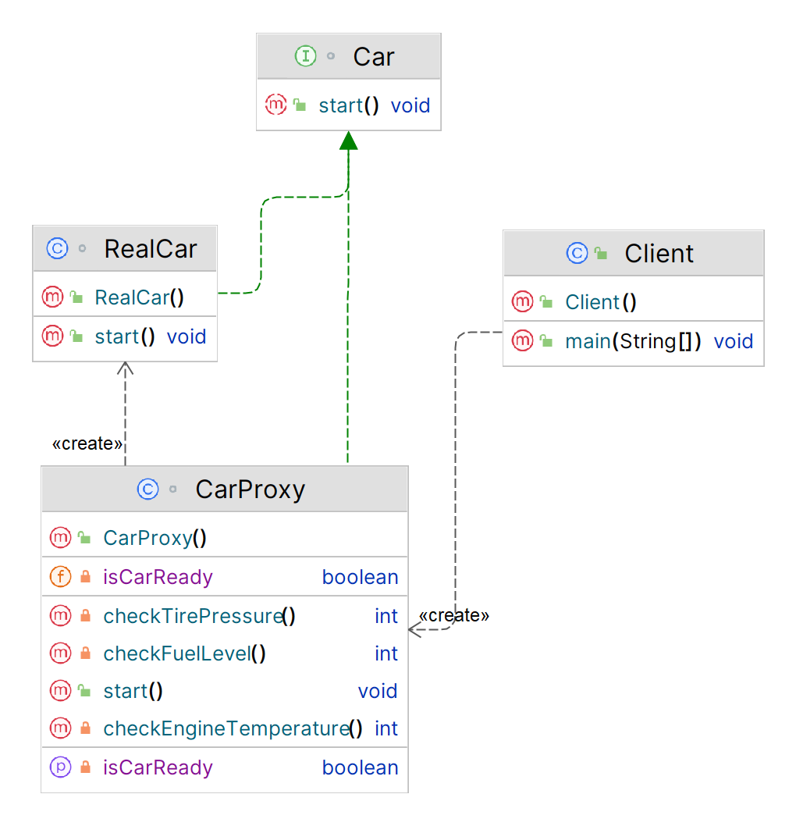

**Implementation (Code)**

|  |
| --- |
| ***// Subject interface***interface Car {  void start(); }  ***// Real subject***class RealCar implements Car {  public void start() {  System.*out*.println("Starting the car");  } }  ***// Proxy***class CarProxy implements Car {  private RealCar realCar;  private boolean isCarReady;  private int fuelLevel;  private int tirePressure;  private int engineTemperature;   public void start() {  if (realCar == null) {  realCar = new RealCar();  }  if (isCarReady()) {  realCar.start();  }  }   private boolean isCarReady() {  if (!isCarReady) {  System.*out*.println("Checking the car's status...");  fuelLevel = checkFuelLevel();  tirePressure = checkTirePressure();  engineTemperature = checkEngineTemperature();  isCarReady = fuelLevel > 0 && tirePressure > 0 && engineTemperature < 100;  }  return isCarReady;  }   private int checkFuelLevel() {  *// Perform checks to determine the fuel level* int fuelLevel = 50; *// Set to 50 for demonstration purposes only* System.*out*.println("Fuel level: " + fuelLevel);  return fuelLevel;  }   private int checkTirePressure() {  *// Perform checks to determine the tire pressure* int tirePressure = 30; *// Set to 30 for demonstration purposes only* System.*out*.println("Tire pressure: " + tirePressure);  return tirePressure;  }   private int checkEngineTemperature() {  *// Perform checks to determine the engine temperature* int engineTemperature = 90; *// Set to 90 for demonstration purposes only* System.*out*.println("Engine temperature: " + engineTemperature);  return engineTemperature;  } }  ***// Client code***public class Client {  public static void main(String[] args) {  Car car = new CarProxy();  car.start();  } }  **Output:** |
|  |

**Applicability**

1. **Lazy initialization** **(virtual proxy):** This is when you have a heavyweight service object that wastes system resources by being always up, even though you only need it from time to time.
2. **Access control (protection proxy):** This is when you want only specific clients to be able to use the service object; for instance, when your objects are crucial parts of an operating system and clients are various launched applications (including malicious ones).
3. **Local execution of a remote service (remote proxy):** This is when the service object is located on a remote server.
4. **Logging requests (logging proxy):** This is when you want to keep a history of requests to the service object.
5. **Caching request results (caching proxy):** This is when you need to cache results of client requests and manage the life cycle of this cache, especially if results are quite large.
6. **Smart reference:** This is when you need to be able to dismiss a heavyweight object once there are no clients that use it.